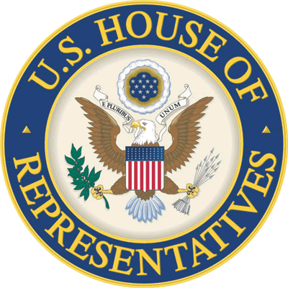
FY 2025 Members’ Submissions
House Committee on Appropriations
Office of Representative Earl L. ‘Buddy’ Carter
Community Project Funding Request Form

DEADLINE: May 1st, 2024

Member Information: YOUR INFORMATION:
Rep. Earl L. ‘Buddy’ Carter Name: Name
2432 Rayburn House Office Building Organization: Organization
(202) 225-5831 Email: Email Address
Phone: Phone

COMMUNITY PROJECT FUNDING REQUEST GENERAL INFORMATION:
- Project Name:

- Project Location:

- Project Sponsor:

- Requested Amount:

- Subcommittee:

- Division/Agency:

- Description and Justification of Request:

- Federal Authorization Law:

- Community Support? (Y/N - Must have demonstrated community support. See below for details and examples.)

- Priority (if submitting more than one):

Community Project Funding Requirements:

The House Committee on Appropriations is accepting Community Project Funding (CPF) requests from Members of the U.S. House of Representatives for Fiscal Year 2025. This is in addition to the standard programmatic and language-based requests. Each Member is limited to no more than 15 Community Project Funding requests across all subcommittees for FY2025. The funding process will be highly selective and there is no guarantee that any of the requested projects will be funded.

The FY2025 CPF process has a limited scope with combined earmarks capped at 0.5% of all discretionary spending, must have a federal nexus tied to a federal authorization law, must follow good stewardship requirements (like cost-share or audit requirements), and eligible accounts are restricted to those listed in the table below.

Further, each Subcommittee has released specific guidelines for projects under its jurisdiction. Specific Subcommittee guidance can be found HERE.

Please note:

- Rep. Carter CANNOT accept CPF requests for projects outside of Georgia.
- All projects must meet relevant statutory and administrative criteria for funding through the grant program under which it is submitted.
- A request submitted to Rep. Carter does NOT guarantee the project will be selected, and the selection of a project for formal submission does NOT guarantee it will be funded by the Appropriations Committee.
- The Committee will NOT provide cost-share waivers and grantees are legally responsible for meeting the non-federal cost share requirements and all other applicable grant criteria.

The posted deadline for submitting project requests to Rep. Carter is close of business on May 1, 2024.

Eligible Entities & Projects
Only state and local government entities, public institutions, and certain non-profit entities are eligible to submit and receive funding through CPF. Funding cannot be directed to for-profit entities and will not include waivers for State or local match requirements. While matching funds do not have to be in-hand prior to the request, requesting entities must have a plan to meet such requirements for the project to be viable. Additionally, each submission must be for FY2025 only and cannot include multi-year funding requests.

The Committee will only consider projects with demonstrated merit and community support in the form of letters from local elected officials; press articles highlighting need; support from newspaper editorial boards; mentions on State intended use plans, community development plans, or other publicly available planning documents; resolutions passed by city councils or boards; etc.

Eligible Accounts by Subcommittee
Descriptions of eligible accounts can be found here.

Agriculture, Rural Development, Food and Drug Administration, and Related Agencies
- Department of Agriculture–Farm Production and Conservation Programs
  - Natural Resources Conservation Service (Conservation Operations)
- Department of Agriculture–Research, Education, and Economics
  - Agricultural Research Service (Buildings and Facilities)
- Department of Agriculture–Rural Development
  - Rural Housing Service (Community Facilities)
  - Rural Utilities Service (ReConnect Program)
  - Rural Utilities Service (Distance Learning and Telemedicine Grants)
  - Rural Utilities Service (Rural Water and Waste Disposal Grants)

Commerce, Justice, Science, and Related Agencies
- Department of Commerce
  - NIST—Scientific and Technical Research
  - NOAA—Coastal Zone Management
- Department of Justice
  - COPS Technology and Equipment
  - Byrne Justice
- National Aeronautics and Space Administration
  - Safety, Security, and Mission Services

Energy and Water Development
- Army Corps of Engineers (Civil Works)
  - Investigations
  - Construction
  - Mississippi River and Tributaries
  - Operation and Maintenance
- Department of the Interior/Bureau of Reclamation
  - Water and Related Resources

Homeland Security
- Federal Emergency Management Agency
  - Federal Assistance—Emergency Ops. Centers
  - Federal Assistance—Pre-Disaster Mitigation

Interior, Environment, and Related Agencies
- Environmental Protection Agency
  - STAG—Clean Water State Revolving Fund
  - STAG—Drinking Water State Revolving Fund

Military Construction, Veterans Affairs, and Related Agencies
- Army
- Army National Guard
- Army Reserve
- Navy & Marine Corps
- Navy Reserve
- Air Force and Space Force
- Air National Guard
- Air Force Reserve
- DoD, Defense-Wide

Transportation, and Housing and Urban Development, and Related Agencies
- Department of Housing and Urban Development
  - CDBG – Economic Development Initiatives
- Department of Transportation
  - Airport Improvement Program
  - Highway Infrastructure Projects
  - Transit Infrastructure Projects
  - Consolidated Rail Infrastructure and Safety Improvements
  - Port Infrastructure Development Program

